**Stanford University Library Management System (LMS)**



**NAME: AKHIL TAMAGAGDE**

**TABLE OF CONTENT**

|  |
| --- |
| PROJECT OVERVIEW |
| AS-IN PROCESS MAP |
| FUTURE PROCESS MAPS |
| UML CASE DIAGRAM |
| MAIN FEATURES |
| IN SCOPE AND OUT OF SCOPE |
| DATA FLOW DIAGRAM & ER DIAGRAM |
| FUNCTIONAL AND NON-FUNCTIONAL REQUIREMENTS |
| WIREFRAMES |

**PROJECT OVERVIEW**

Stanford University is a private research university in California. The university was founded in 1885 and as of today, 83 Nobel laureates, 28 Turing Award laureates, and 8 Fields Medalists have been affiliated with Stanford as students, alumni, faculty, or staff.

For the benefit of the students, Stanford started its own library in 1885. The library at Stanford was housed in one large room capable of accommodating 100 readers. As the university grew to enroll more than 20,000+ students in a given year the library grew as well. Today the library boasts of having more than 4 million books in it.

The paper-based maintaining, organizing, and handling of countless books became a nightmare. The university wanted a Library Management Software to automate their library’s activities. Using the software one can find books with a click, issue/reissue books quickly, and it will manage all the data efficiently using this system. It also provides immediate and accurate information regarding any type of book, magazine, or research paper, thereby saving a lot of time and efforts.

**AIM OF PROJECT**

Managing the university library with a traditional paper-based system has become challenging, making it difficult to organize and maintain a vast collection. To address this, the university is adopting library management software to automate and streamline operations. The software allows quick book searches, speeds up issuing and reissuing, and ensures accurate, up-to-date records. It also provides instant, precise information, reducing time and effort. This system aims to enhance efficiency, save time, and improve the user experience.

**IDENTIFYING STAKEHOLDERS**

This framework ensures clear roles, fosters collaboration, and simplifies the management of responsibilities and communication, as recommended by the BABOK Guide. In a RACI matrix, Responsible (R) refers to those performing the task, while Accountable (A) designates the individual ultimately responsible for its success. Consulted (C) involves stakeholders who provide expertise and feedback, and Informed (I) includes those who are updated on progress without direct involvement.

|  |  |  |  |  |
| --- | --- | --- | --- | --- |
| **Stakeholders** | **Responsible** | **Accountable** | **Consulted** | **Informed** |
| Business Analyst | **R** |  |  |  |
| Project manager | **R** |  |  |  |
| Library manager (DSME) |  | **A** | **C** |  |
| Technical team (ISME) | **R** |  |  |  |
| Students |  |  |  | **I** |
| Faculty |  |  |  | **I** |
| Regulator | **R** |  |  |  |
| Library staff | **R** |  |  |  |
| Tester | **R** |  |  |  |
| Sponsor |  |  | **C** |  |

**PROBLEM STATEMENT**

Time-Intensive: Manual library management is slow due to tasks like organizing and updating records.

High Staffing: The system needs many staff, increasing labor costs.

Cumbersome Fines: Manually calculating fines is tedious and error-prone.

No Reports: The manual system can't generate reports, limiting oversight.

Inventory Challenges: Managing 4 million books manually leads to stock issues.

Restricted Returns: Students can only return books during library hours, limiting convenience.

**VALUE / ISSUE OBJECTIVE**

* Minimize overhead and enhance library staff efficiency.
* Reduce expenses.
* Keep records of all library materials current.
* Boost student involvement in the library.
* Produce dynamic reports for improved decision-making.

**TRANSITION**

Adopt a Library Management System to automate library operations.

**RESOLUTION**

Automate library tasks to enable easy book searches, swift issuing/reissuing of materials, and efficient data handling. The system delivers prompt and precise information on books, magazines, and research papers, conserving time and effort.

### CONTEXT

The software allows effortless book searches, expedites the issuing/reissuing process, and manages data effectively. It provides quick, accurate information on all materials, greatly reducing time and effort.

**ADVANTAGES OF NEW LMS**

* **Lower Costs and Boost Staff Efficiency**: Reduce expenses and enhance library staff productivity.
* **Cost Savings**: Achieve reduction in costs.
* **Current Inventory**: Maintain up-to-date records of all library materials.
* **Enhance Student Interaction**: Increase student involvement in the library.
* **Generate Insightful Reports**: Produce dynamic reports for informed decision-making.

**PROCESS MAP**

As in flow:

Future flowchart:

**MAIN FEATURES TO BE DEVELOPED**

* Implement secure login and registration to ensure only authorized students and staff can access and manage library resources.
* Use RFID tags and readers for tracking materials and preventing theft, enhancing inventory management and security.
* Automatically calculate fines for overdue books to streamline the process and ensure accurate assessments.
* Provide access to the LMS via web and mobile platforms for convenient account management and material search.
* Send automated email notifications 3 days before book return dates to help prevent late returns and reduce fees.
* Search of books with their criteria
* User being able to check for date of return in the LMS website or app.
* Access to E-Resource

**IN SCOPE**

1. **User Authentication**: Implement secure role-specific access for authorized users.
2. **Alert System**: Set up automated notifications for key activities and issues.
3. **Dropbox Integration**: Enable cloud storage and sharing via Dropbox within the LMS.
4. **Digital Library Access**: Provide an online repository for e-books and scholarly journals.
5. **RFID Access Control**: Utilize RFID technology for tracking entry and monitoring presence.
6. **Book Circulation**: Develop a system for lending, renewing, and tracking physical books.
7. **Penalty Collection**: Integrate a system to calculate and collect penalties for overdue items.
8. **Email Notifications**: Automate email alerts for due dates, overdue items, and penalty payments.

**OUT OF SCOPE**

* **Book Sales**: Implement a system for purchasing books directly through the platform.
* **Newspaper Borrowing**: Enable the checkout and return of newspapers.
* **Guest Access**: Provide regulated entry to the LMS for external users.
* **Membership Handling**: Develop a system to manage and oversee user memberships.
* **Book Overviews**: Include a feature that offers concise summaries of books.
* **Mobile Application**: Develop an app for easy access to the LMS on mobile devices.
* **User Book Contributions**: Create a platform for users to donate books to the collection.

**DATA FLOW DIAGRAM – CONTEXT DIAGRAM**

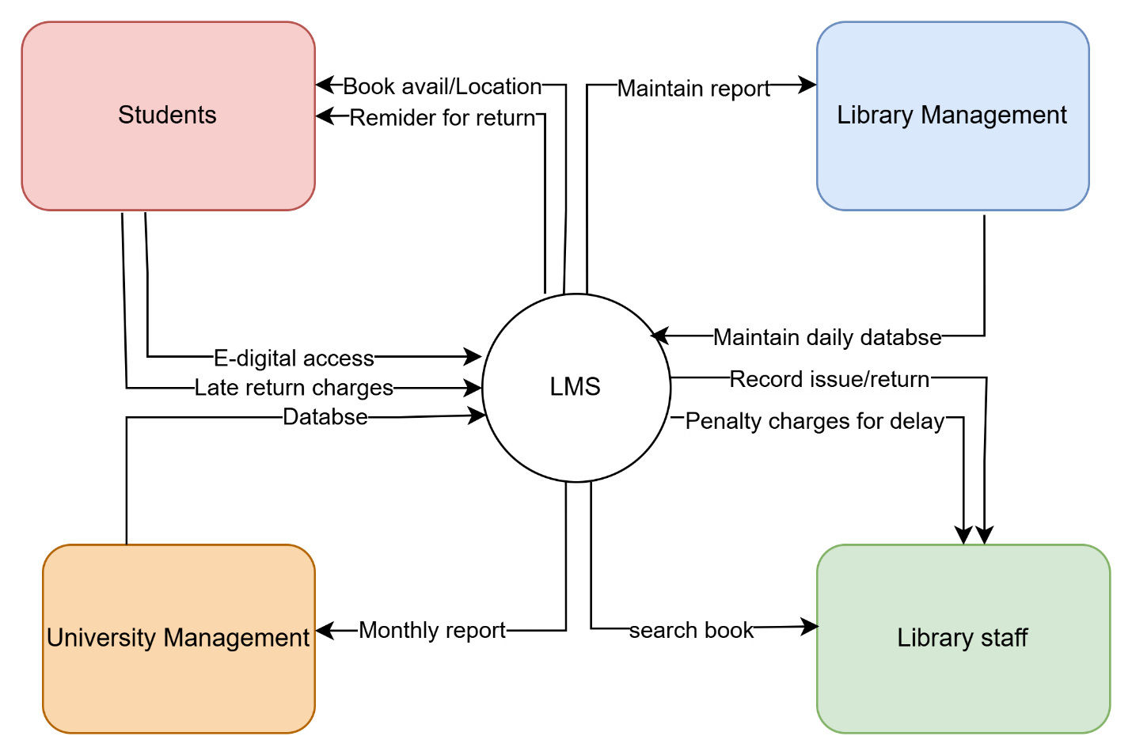

**ER DIGRAM**

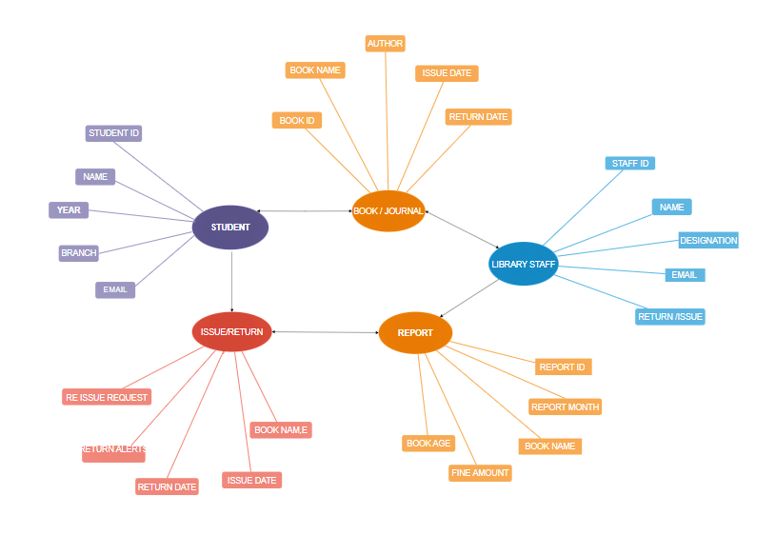

**FUNCTIONAL REQUIREMENT**

* **Material Inventory**: Maintain records for various categories of available items.
* **Subject Organization**: Categorize books by their subject area.
* **Lending Period Configuration**: Set borrowing durations for each type of material
* **RFID-Tagged Items**: Attach RFID tags to physical resources with detailed information.
* **Student ID and RFID Connection**: Associate student IDs with RFID tags for seamless checkouts.
* **Return Date and Penalty Automation**: Automate the update of due dates and penalty calculations.
* **Book Search Filters**: Enable users to locate books using specific filters.
* **Automated Notifications**: Set up automatic alerts for users.
* **RFID Security System**: Use RFID technology to implement a security system against theft.
* **Return Station**: Provide a drop box station for easy returns.
* Automated Reports: Produce automated statistics and insights.

**NON FUNCTIONAL REQUIREMENTS**

**Ease of Use**: The system should be intuitive and user-friendly.

**High Capacity**: It should support more than 20,000 users.

**Expandability**: It should scale with more students without losing performance.

**Dependability**: The system should be reliable, with regular backups and minimal downtime.

**Cross-Platform**: It should work on Windows and MacOS, be RFID-compatible, and require internet access.

**Security and Privacy**: Ensure the confidentiality of student and staff data.

**WIREFRAME**

